Are there two sides to every story?
We are creators
Summer Term 2 - 2026
Aim to score at least 8 points this half term.
Upload what you’ve done to Class Dojo or bring in your finished items in to share.

Weekly Essentials
Read five times per week. | Play Times Tables Rock Stars | Practise your spellings

  5 points | Visit an art gallery.  Derby Museum and Art Gallery and Nottingham Contemporary are both free to enter.  https://www.derbymuseums.org/museum-and-art-gallery/  https://www.nottinghamcontemporary.org/ |  |  | Bake a cake that is different on each side. Maybe different layers? Or icing on the top to decorate?  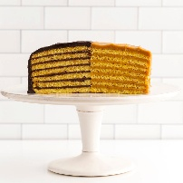
  3 points | Create a repeated pattern in the style of M.C. Escher  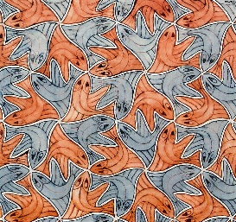 |  | Use salt, glue and paints to make a sparkly tessellation |  | Create a new front cover for ‘Peanut Jones and the Illustrated City’.  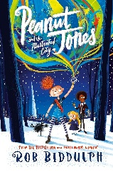
  2 points | 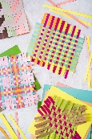  Create an identical paper weave | Create a simple shape stencil |  | Create a new front cover for ‘Peanut Jones and the Illustrated City’. |  | Find out about a famous magician in the world.

